From the diary of James McWhinney – Telegraph Linesman, Marble Bar, 1919-20 held by the Battye Library, Perth, WA.
(see also McKenzie, John A. 1978 ‘An Exile in Marble Bar: the Diary of a Telegraph Linesman 1919-20’ Early Days Journal Vol VIII Part II, pp. 5-30. The Royal Western Australian Historical Society (inc).
After leaving the [Ethel Creek] race course, we passed a hill about a mile off the road. This hill is called “Battle Hill”. I made a few inquiries about Battle Hill and was told that years ago, a man named MacKay, known as “Buller” MacKay, I don’t know what profession he followed, but I gather he came to these parts in the early days as a settler, and in those days the blacks were wild, and not very friendly with the whites, and they followed this MacKay for several days and at last he found, that it was no use trying to get away without a fight, as the blacks were closing in on them, they fought the blacks on this hill, the blacks won the fight, MacKay got away, And the chief of the tribe reckoned he owned that part of the country afterwards. And the hill has been known as Battle Hill ever since. But a peculiar coincidence happened in this case, on driving along we came to a motor car, they had been on the road all night, and were half drunk, and covered in dust and dirt, the owner of the car a Mr Lindross, was repairing a punctured tube, and in the car as a passenger was the son of this “Buller MacKay” named “Roy MacKay”. He is a big fat man of middle age now. I felt like asking him some questions about the “father” but his condition was not quite normal, so I was content with the few inquiries I had already made. We arrived back in Roy Hill. Then on to Bonnie Downs, and into Nullagine, again on Sunday morning. Left for Marble Bar on Monday, about midday, we came the rest of the journey by easy stages as the camels were getting weary, and arrived in Marble Bar on Thursday morning at 9 o’clock 1st May 1919.
End of Chapter No. 5.

Note Donald MacKay was known as “Bunga” which means “Big Stomach” He was born in1833 in Scotland and died on 24th December 1901. This is similar to “Buller” as in the diary. His son to Marion McLeod was John Shaw Mackay of Roy Hill born in 1874 and died on 12th August 1916. John Shaw Mackay had a son Alec Mackay to an Aboriginal woman named Maggie. Maggie was also the mother of Roy and Gordon who were also called Mackay. If Roy was born on 22 June 1900 he would not be ‘middle aged’ in 1919 as the diary says. Maggie had another son William to Bill Coffin who died in 1829. So Alec, Roy, Gordon and William were brothers.
See also Taruru: Aboriginal songs from the Pilbara by C G von Brandenstein and A P Thomas. Rigby, 1974, p.65

Below is from C G von Brandenstein, "NARRATIVES FROM THE NORTH-WEST OF WESTERN AUSTRALIA IN NJIJAPALI, LANGUAGE OF THE PALJGU VOLUME I " (1968)
p.XVIII Gordon Mackay-Wanna [aged] 72, of Marble Bar, W.A., has narrated Nos. 1-13, 15-32, 34-40, 46-51; in Nos. 15, 17, 39 he converses with Hickey and in no.38 with his younger brother Roy. Gordon Mackay-Wanna, the dominant figure among Njijapali narrators, went to school in Perth. Though he can read and write he was really never keen to practise it. He preferred station life and station work. After years on some coastal stations he drove cattle from Roy Hill to Port Hedland, An accident in which he was kicked by a horse, made him retire, first to Port Hedland and later to Marble Bar. The latter place appealed to him more since Port Hedland became industrialised.
Gordon is a Pannaga, but he could easily be taken for a Paltjarri because of his gentle and friendly nature. His keen sense of justice and tactfulness make him a real offspring of the Paljgu heroes, the Tamiarra or 'gentlemen'. But there is no need to describe the qualities of Gordon's character. The subtlety and flourish of his diction speaks out for him. To compare his verbal style with that of Robert Churnside, the Ngarluma speaker of Part I, is like reading Greek and then compare it with Latin,
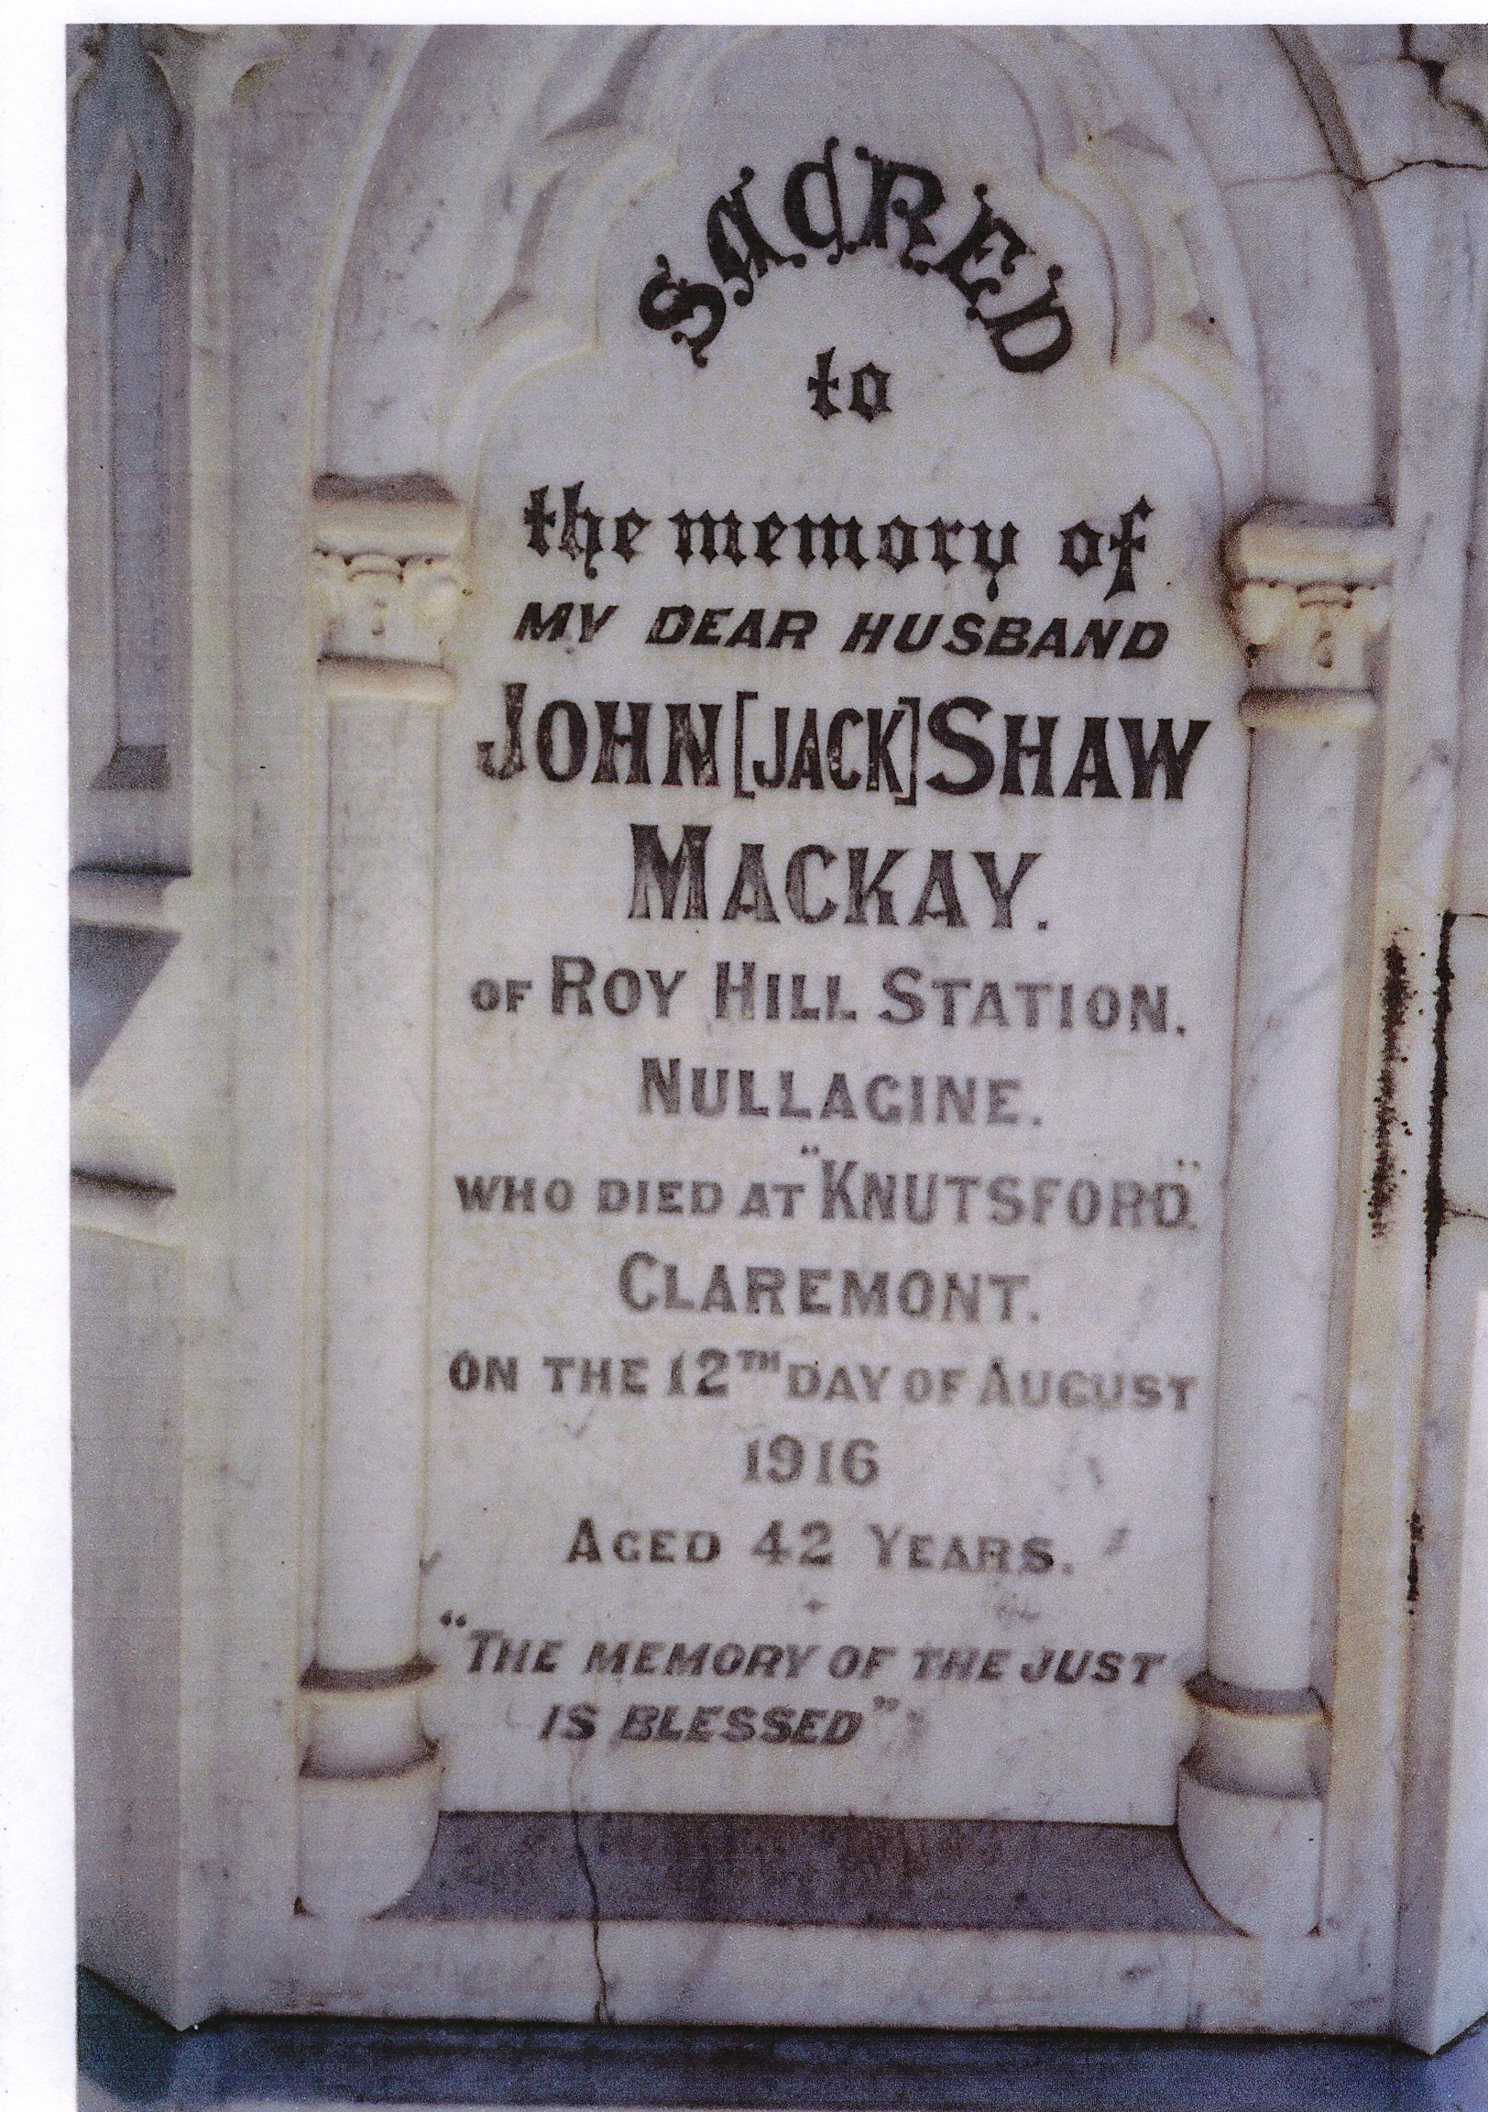
Above: Grave of J.S. Mackay in Fremantle cemetery

